**Module 12: Windows Server**

1. **What two options are provided in the type of installation window during Windows Server 2016 installation?**
   * **Server Core** installation
   * **Desktop Experience** (Full GUI) installation
2. 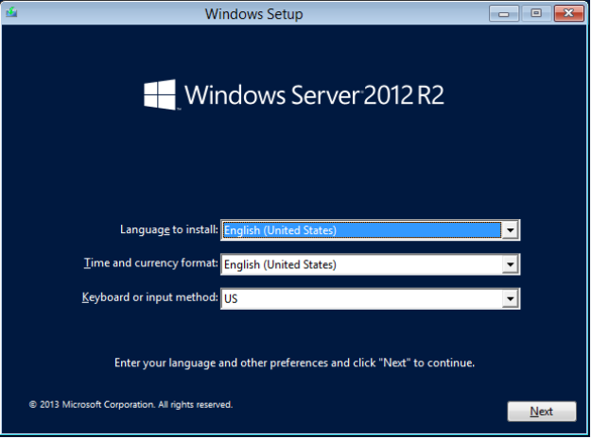**How to configure the server step by step?**
   * Install Windows Server
   * Set up initial configurations using **Server Manager**
   * Assign a static IP address
   * Configure the server name
   * Set up remote access
   * Install necessary roles and features
   * Update the system
   * Configure security settings
   * Join a domain (if applicable)
3. **What are the Pre-installation tasks?**
   * Verify hardware requirements
   * Backup critical data
   * Select the appropriate Windows Server edition
   * Plan for network configuration
   * Prepare installation media (DVD, USB, ISO)
4. **What are the Post-installation tasks?**
   * Configure network settings
   * Install Windows updates
   * Install and configure roles and features
   * Set up security policies
   * Configure backups and monitoring
5. **What is the standard upgrade path for Windows Server?**
   * Windows Server 2012 → Windows Server 2016
   * Windows Server 2012 R2 → Windows Server 2016
6. **What is the Physical structure of AD?**
   * Domain Controllers
   * Sites
   * Subnets
7. **What are the Logical components of Active Directory?**
   * Domains
   * Trees
   * Forests
   * Organizational Units (OUs)
8. **What is the Full form Of LDAP?**
   * **Lightweight Directory Access Protocol**
9. **What is the location of the AD database?**
   * C:\Windows\NTDS\NTDS.DIT
10. **What is a child DC?**
    * A **child domain controller** is a **sub-domain** under a parent domain in an Active Directory forest.
11. **Explain the term forest in AD.**
    * A **forest** is the highest level of the Active Directory hierarchy that contains multiple domains sharing a common schema.

**Assignment: Windows Server**

1. **What is Active Directory? Check all that apply.**

* ✅ A Windows-only implementation of a directory server
* ✅ Microsoft's implementation of a directory server
* ✅ An LDAP-compatible directory server

1. **When you create an Active Directory domain, what's the name of the default user account?**

* ✅ **Administrator**

1. **AD domain provides which of the following advantages? Check all that apply.**

* ✅ Centralized authentication
* ✅ More detailed logging
* ✅ Centralized management with GPOs

1. **What are the minimum hardware requirements for installing Windows Server 2016?**

* **Processor:** 1.4 GHz 64-bit
* **RAM:** 512 MB (Server Core), 2 GB (Desktop Experience)
* **Storage:** 32 GB minimum

1. 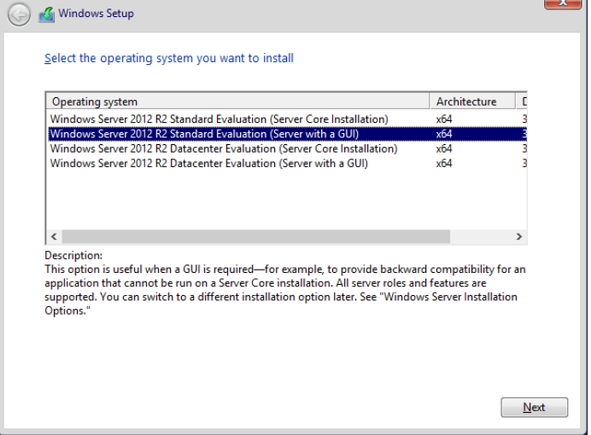**Explain the different editions of Windows Server 2016 and their features.**

* **Windows Server 2016 Essentials:** Small businesses, up to 25 users
* **Windows Server 2016 Standard:** Medium-sized businesses, virtualization support
* **Windows Server 2016 Datacenter:** Enterprise-level, advanced virtualization

1. **Walk through the steps of installing Windows Server 2016 using GUI mode.**

* Boot from installation media
* Select language and time settings
* Choose **Windows Server (Desktop Experience)**
* Configure disk and partition
* Complete installation and restart
* Configure initial settings (network, name, updates)

1. **Describe the steps for installing Windows Server 2016 in Server Core mode.**

* Boot from installation media
* Choose **Windows Server Core**
* Complete installation and restart
* Use **sconfig** for basic setup
* Configure network and roles using PowerShell

1. **How do you configure network settings during Windows Server 2016 installation?**

* Use **sconfig** (for Server Core)
* Use **Control Panel > Network and Sharing Center** (for GUI)
* Assign static IP, subnet mask, and DNS

1. **Explain the process of promoting a Windows Server to a domain controller.**

* Install **Active Directory Domain Services (AD DS)**
* Use **Server Manager** or PowerShell
* Run **dcpromo** or Install-ADDSForest cmdlet
* Follow the wizard to set up the domain

1. **Discuss the steps involved in upgrading from a previous version of Windows Server to Windows Server 2016.**

* Back up existing server
* Check hardware compatibility
* Insert installation media and run **setup.exe**
* Choose **Upgrade**
* Follow the installation process

1. **What is Active Directory Domain Services (AD DS), and what are its key components?**

* AD DS provides authentication and directory services
* **Key components:** Domains, OUs, Trees, Forests, Domain Controllers

1. **How do you create a new Active Directory user account in Windows Server?**

* Open **Active Directory Users and Computers (ADUC)**
* Right-click on an OU > **New > User**
* Enter details and set a password

1. **Explain the process of creating and managing Group Policy Objects (GPOs) in Windows Server 2016 or 2019.**

* Open **Group Policy Management Console (GPMC)**
* Create a new GPO
* Link it to a domain or OU
* Configure policy settings

1. **What are Organizational Units (OUs) in Active Directory, and how do you use them?**

* OUs are logical containers for grouping users, computers, and groups
* Used for **delegation of administrative tasks and applying GPOs**

1. **Describe the process of delegating administrative privileges in Active Directory.**

* Open **Active Directory Users and Computers**
* Right-click an OU > **Delegate Control**
* Select users/groups to delegate
* Assign administrative tasks